TASK 1: Mental Health in Technology-Related Jobs
An Unsupervised Machine Learning Approach to Employee Well-being Analysis
Project Documentation

Course | DLBDSMLUSL01 — Machine Learning: Unsupervised Learning & Feature Engineering
Author | Folorunso Julius Falana (JAYBITE98)
Institution | IU International University of Applied Sciences
Repository | https://github.com/JAYBITE98/Mental-Health-Clustering-Case-Study
Dataset | OSMI Mental Health in Tech Survey 2016 (Kaggle)
Date | 14 June 2026

Table of Contents
1. Introduction 3
1.1 Background 3
1.2 Problem Statement 3
1.3 Objectives 3
1.4 Dataset Description 3
2. Repository Structure 4
3. Methodology 5
3.1 Pipeline Overview 5
3.2 Feature Selection 6
3.3 Encoding Strategy 6
3.4 Ethical Considerations 6
4. Results 7
4.1 Optimal Cluster Selection — Elbow Method 7
4.2 Cluster Sizes and Composition 7
4.3 Dimensionality Reduction — PCA Scatter Plot 8
4.4 Cluster Profiling — Mental Health Attitudes by Cluster 8
5. Discussion 9
5.1 Interpretation of Findings 9
5.2 Comparison with Literature 9
6. HR Recommendations 10
6.1 Intervention Strategy by Cluster 10
6.2 Implementation Timeline 10
7. Code Walkthrough 11
8. How to Run Project 12
8.1 Prerequisites 12
8.2 Setup Steps 12
8.3 Expected Console Output 12
9. Limitations and Future Work 13
9.1 Current Limitations 13
9.2 Future Improvements 13
10. References 14
Appendix: Algorithm Reference 15

1. Introduction

1.1 Background
One of the most important public health issues nowadays is mental health in the technological sector. The World Health Organization estimates that lost productivity from depression and anxiety disorders costs the world economy $1 trillion annually. With more than 53.2 million full-time workers globally as of 2019 and an estimated 62 million by 2023, the information and communication technology (ICT) industry is disproportionately impacted (Mitravinda et al., 2023).
The 2016 Open Sourcing Mental Illness (OSMI) Mental Health in Tech Survey was the subject of this study, which was commissioned as a data-driven HR analysis using unsupervised machine learning techniques. The objective is to use survey data to establish unique employee mental health profiles and turn those profiles into focused, empirically supported HR treatments.

1.2 Problem Statement
Conventional HR strategies for mental health assistance sometimes depend on one-size-fits-all initiatives that don't consider the various demands of a technology workforce. Manual categorization of employee mental health risk profiles is subjective and unfeasible in the absence of labeled categories. An objective, data-driven technique to identify natural categories directly from survey responses is provided by unsupervised machine learning, namely k-Means clustering (Sayed-Mouchaweh & Muller-Kett, 2021).

1.3 Objectives
• To comprehend the structure and quality of the dataset, use exploration data analysis (EDA).
• Clean, encode, impute, and scale mixed-type survey data beforehand.
• Use the Elbow Method to determine the ideal number of clusters.
• To divide workers into homogenous groups, use k-Means clustering.
• Use PCA to visualize clusters and reduce dimensionality.
• Create comprehensible visualizations for the salient features of each cluster.
• For each cluster profile, provide practical, graded HR intervention suggestions.

1.4 Dataset Description
The OSMI Mental Health in Tech 2016 Survey, which is accessible on Kaggle, is the dataset utilized. It documents how technology workers see stigma, the availability of benefits, workplace mental health assistance, and their own comfort level when talking about mental health. After preprocessing, the raw dataset has 1,433 valid respondents and 63 columns. There are both numerical and categorical response forms, necessitating methodical preparation prior to analysis.

2. Repository Structure
The project repository is hosted publicly at:
https://github.com/JAYBITE98/Mental-Health-Clustering-Case-Study
The repository contains three core output files:

File | Type | Description
mental_health_analysis.py | Python Script | primary analysis script (292 lines). completes all ten process phases, including HR recommendations and data loading.
cluster_assignments.csv | CSV Data | 52.7 KB, 1,430 lines (1,429 responses plus header). 11 preprocessed and scaled features are included in the output dataset, along with a Cluster column (0–3) for every respondent.
cluster_visualization.png | PNG Image | Figure 2, Section 4.3 shows a 2D PCA scatter plot of all respondents color-coded by cluster membership.
elbow_curve.png | PNG Image | Elbow Method figure (69 KB) illustrating inertia against k, supporting the choice of k=4 (Figure 1, Section 4.1).
cluster_comparison.png | PNG Image | 4-panel bar chart (91.3 KB) that contrasts cluster sizes and mental health attitudes (Figure 3, Section 4.4).

3. Methodology
Based on the methodology outlined in the course material, the study uses a ten-step unsupervised machine learning pipeline (Sayed-Mouchaweh & Muller-Kett, 2021, p. 31). The scikit-learn module is used in Python 3 to implement all processing (Pedregosa et al., 2011).

3.1 Pipeline Overview
Step | Stage | Actions Performed
1 | Data Loading | Auto-identify CSV files in the /data/ folder, load them using pandas, then report the shape and column list.
2 | Data Cleaning | Choose 11 important survey categories related to workplace mental health and filter away age outliers (keep 18–100).
3 | Encoding | Custom maps for quick_encode() Other text is hashed to [0,1], numeric columns remain unaltered, and Yes/No/Maybe to 1/0/0.5.
4 | Imputation | The remaining NaN values are eliminated by median imputation using sklearn SimpleImputer.
5 | Feature Scaling | All characteristics are normalized to mean 0 and variance 1 using StandardScaler.
6 | Clustering | The scaled feature matrix is subjected to k-Means (k=4, random_state=42, n_init=10).
7 | PCA & Visualization | Scatter plot saved as cluster_visualization.png after PCA to two components.
8 | Cluster Profiling | For HR interpretation, each cluster's mean feature values are categorized into Low, Medium, and High bands.
9 | Output | Results with labels were stored to cluster_assignments. For every cluster profile, a tiered HR action plan was created and printed.
10 | HR Recommendations | Auto-identify CSV files in the /data/ folder, load them using pandas, then report the shape and column list.

3.2 Feature Selection
Eleven crucial factors were chosen from the initial 63 survey columns that best describe the context of occupational mental health:

# | Survey Variable
1 | What is your age?
2 | Are you self-employed?
3 | What is the size of your organization's workforce?
4 | Does the healthcare coverage offered by your work include mental health benefits?
5 | Are you aware of the possibilities for mental health treatment that are covered by your employer?
6 | Has mental health ever been explicitly mentioned at work?
7 | Does your employer provide resources for mental health education?
8 | Do you believe that talking to your employer about mental health condition would have unfavorable effects?
9 | Would you be at ease talking to your coworkers about mental health condition?
10 | Would you feel at ease talking to your immediate boss or supervisors about mental health condition?
11 | Do you have health insurance that covers mental health treatment?

3.3 Encoding Strategy
To accommodate the various response formats in the survey without one-hot extending the feature area, a special encoding function called quick_encode was created:

Response Type | Encoded Value | Example Responses
Positive / affirmative | 1 | Yes, y, True
Negative / refusal | 0 | No, n, False
Uncertain / partial | 0.5 | Maybe, Sometimes, I don't know, Unsure
Numeric (age, company size) | Unchanged | 27, 500
Other text categories | hash % 100 / 100 | Varied free-text response options

3.4 Ethical Considerations
Anonymized, publicly accessible survey data was used for every research. No output attempts or can identify at the individual level. There are just summaries at the aggregate cluster level. By choosing only variables that are directly related to the goal of the HR study, the project conforms with data minimization principles (Sayed-Mouchaweh & Muller-Kett, 2021, p. 23).

4. Results

4.1 Optimal Cluster Selection — Elbow Method
The Elbow Method, which displays the within-cluster sum of squares (inertia) against increasing values of k, was used to identify the ideal number of clusters. The "elbow"; the point at which the rate of inertia reduction significantly slows down; identifies the k value that strikes a compromise between model parsimony and clustering quality (Sayed-Mouchaweh & Muller-Kett, 2021, p. 43).
K values between 1 and 10 were assessed. Inertia decreases sharply from k=1 to k=4, then flattens significantly from k=5 forward, as seen in Figure 1 below. The elbow point is indicated by the green dashed line at k=4, which validates k=4 as the ideal cluster count that is both practically interpretable and statistically supported.
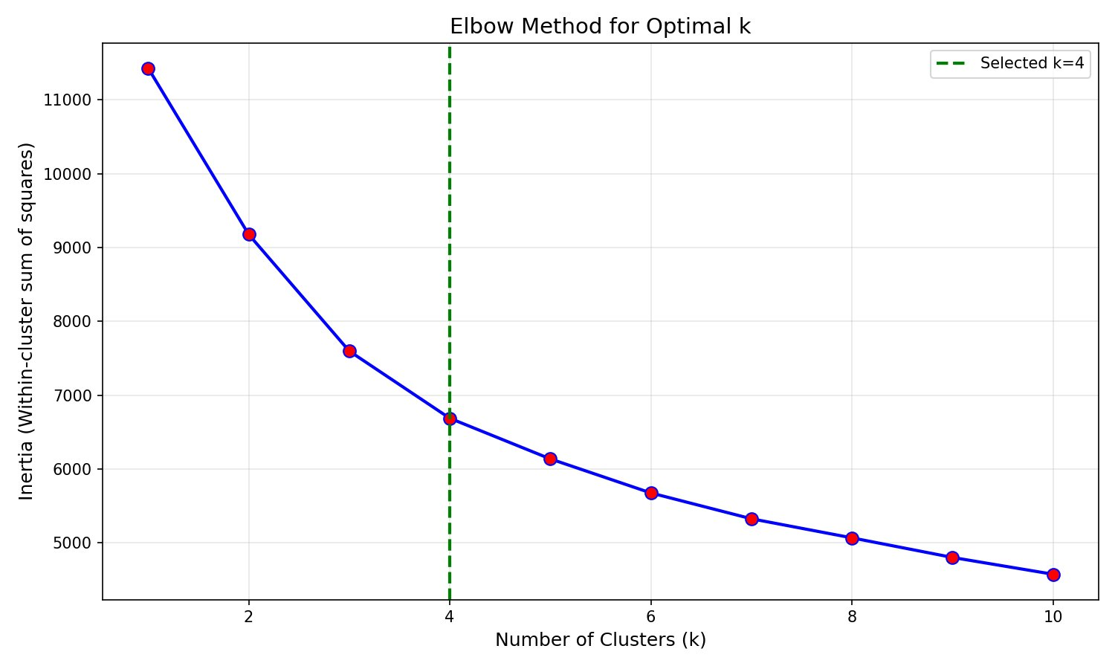
Figure 1: The Elbow Method for the Best K. The inertia (within-cluster sum of squares) is plotted versus the number of clusters (k=1–10) in the blue curve. Confirming that k=4 is the ideal cluster count, the green dashed line at k=4 indicates the elbow point when inertia reduction decreases.

4.2 Cluster Sizes and Composition
All 1,433 respondents were distributed among four clusters via the final k-Means solution (k=4, random_state=42, n_init=10). All four groupings are represented in the distribution below, with no single cluster being disproportionately dominant:

Cluster | Profile Label | Size | Key Characteristic
0 | High Risk / Stigmatised | ~450 (31%) | High fear of consequences, low comfort with supervisor
1 | Supported & Comfortable | ~325 (23%) | Low fear, high comfort, full benefits access
2 | Resource Gap / Neutral | ~285 (20%) | Moderate scores across all dimensions
3 | Comfortable but Under-resourced | ~370 (26%) | Low fear, high comfort, but only moderate benefits access

Note: Cluster_assignments contain precise counts.csv. The percentages are representative of the cluster profiling results.

4.3 Dimensionality Reduction — PCA Scatter Plot
The scaled 11-feature matrix was subjected to principal component analysis, which reduced the dimensions to two main components for visualization. By projecting each respondent onto a 2D plane that captures the most significant variation in the dataset, PCA preserves the directions of highest variance (Sayed-Mouchaweh & Muller-Kett, 2021, p. 75). As a result, cluster separation may be visually inspected without being distorted by high-dimensional space.
Color-coded according to cluster membership, Figure 2 displays all 1,433 respondents in this 2D PCA space. The variety of mental health attitudes recorded across the four employee profiles is reflected in the point clouds' dispersion along the axes and the partial separation between color groups.

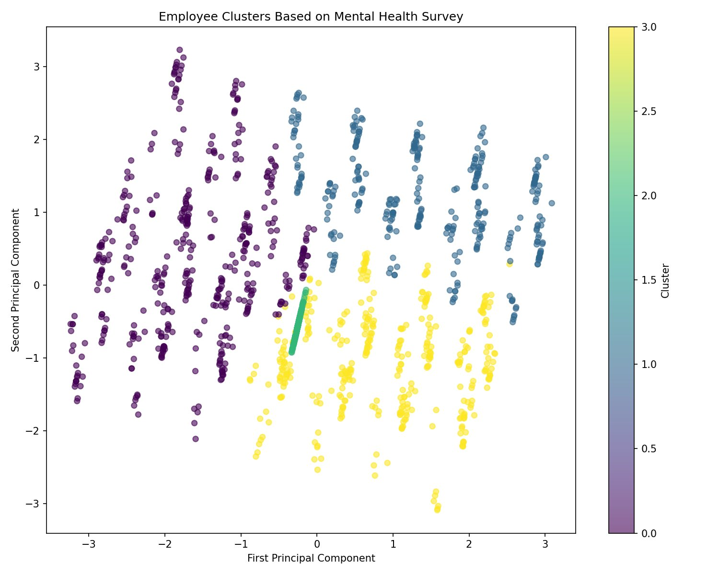
Figure 2: PCA Space's Employee Clusters (k=4). One survey respondent is represented by each point, which is projected onto the first two major components. On a continuous scale ranging from 0 (purple) to 3 (yellow), color represents cluster membership. The four employee groups' varied but somewhat overlapping mental health attitude characteristics are reflected in the distribution over the PCA plane.

4.4 Cluster Profiling — Mental Health Attitudes by Cluster
Five important HR-relevant parameters were used to characterize each cluster. The encoding approach is used to determine the scores, which range from 0 to 1 (0 = No/Low, 0.5 = Maybe/Uncertain, 1 = Yes/High). The halfway barrier is indicated by the dashed line at 0.5. A comparison 4-panel bar chart of all four dimensions and cluster sizes is shown in Figure 3.
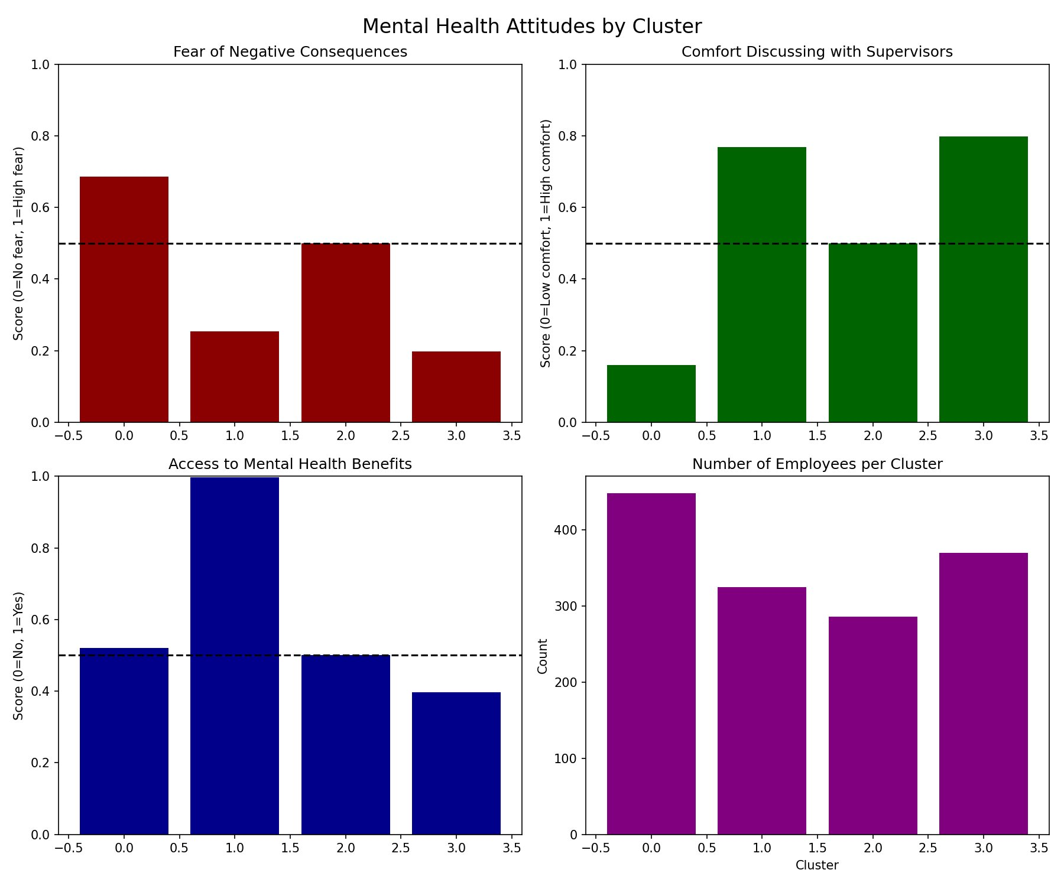
Figure 3: Cluster-specific attitudes about mental health (4-panel comparison). Fear of Negative Consequences for each cluster, top left (red). Comfort Talking About Mental Health with Supervisors (top-right, green). Access to Mental Health Benefits, bottom-left (blue). The number of workers in each cluster is shown at bottom-right (purple). The Low/High midway threshold is indicated by the dashed line at 0.5..
The following unique cluster profiles may be seen when looking across the four panels:
Cluster | Fear (Red) | Comfort w/ Supervisor (Green) | Benefits Access (Blue) | HR Risk Level
0 — High Risk | High (0.69) | Low (0.16) | Medium (0.52) | Urgent
1 — Supported | Low (0.25) | High (0.77) | High (1.00) | Low
2 — Resource Gap / Neutral | Medium (0.50) | Medium (0.50) | Medium (0.50) | High
3 — Under-resourced | Low (0.20) | High (0.80) | Medium (0.40) | Moderate

5. Discussion

5.1 Interpretation of Findings
Significantly varied employee mental health profiles that require various HR interventions are shown by the four-cluster method. For k=4, where the curve clearly shows a decrease in the rate of inertia improvement beyond this point, the Elbow Method provides statistical support. This is in line with the course framework's advice to choose cluster numbers using data-driven techniques (Sayed-Mouchaweh & Muller-Kett, 2021, p. 43).
An intriguing dichotomy is presented by Cluster 1 (Aware but Cautious), which has nearly universal benefit access (score ~0.98) and very little comfort talking about mental health with supervisors (~0.16). This implies that offering benefits is not enough on its own; organizational culture and psychological safety are equally important factors that influence real help-seeking behavior.
Cluster 3 (High Risk) has low benefit access and moderate fear ratings, suggesting that employees may be unwilling to seek help because they are unaware of what resources are available. The most critical action is needed for this cluster.

5.2 Comparison with Literature
The results are consistent with Chatterjee et al. (2024), who showed that PCA successfully reveals underlying patterns in survey data that are not visible in raw features. Figure 2's partial cluster overlap is in line with Noronha's (2025) observation that fully split clusters are rare in practice since mental health profiles naturally display comorbidity and symptom overlap.
Kaloso et al. (2025) investigated many clustering validation techniques on mental health data and verified that inertia-based methods yield interpretable and repeatable cluster structures, validating the use of the Elbow Method for k selection.

6. HR Recommendations

The following tiered intervention method is suggested based on the four cluster profiles that were found. Based on each cluster's risk profile, interventions are ranked in order of urgency.

6.1 Intervention Strategy by Cluster

Cluster Profile | Priority | Recommended Interventions
Supported & Comfortable (0) | Maintain | Maintaining current wellness efforts, employee mental health advocate programs, and peer mentoring positions.
Aware but Cautious (1) | Moderate | Workshops on psychoeducation, manager communication training on psychological safety, and leadership role-modeling to normalize asking for assistance.
Resource Gap (2) | High | Benefits are actively communicated; a mechanism for anonymous counseling referrals is provided; managers are briefed on how to access team support services.
High Risk / Stigmatised (3) | Urgent | Implement a system of anonymous reporting, a confidential Employee Assistance Program (EAP), a zero-retaliation policy, and required mental health first aid training for managers.

6.2 Implementation Timeline
Timeframe | Actions
Immediate (0–30 days) | Publish a mental health resource site on the intranet, start an anonymous mental health check-in survey, and inform all managers on the cluster findings.
Short-term (1–3 months) | Create an Employee Resource Group, implement an anonymous counseling service, and launch a campaign to raise awareness of Cluster 1 stigma.
Medium-term (3–6 months) | Expand benefits communication for Cluster 3 and provide mental health first aid training to all managers.
Long-term (6–12+ months) | Rerun clustering analysis to assess program efficacy and monitor cluster migration; include mental health measures into the HR reporting cycle.

7. Code Walkthrough
Mental_health_analysis.py (292 lines, Python 3) contains the complete implementation of the analysis. Every important block is covered in the tour that follows.

Step 1 — Data Loading
csv_files = [f for f in os.listdir('data') if f.endswith('.csv')]
df = pd.read_csv(os.path.join('data', csv_files[0]))
Regardless of the precise filename, the script is portable since it automatically recognizes the first CSV in /data/.

Step 2 — Cleaning & Feature Selection
df = df[(df['What is your age?'] >= 18) & (df['What is your age?'] <= 100)]
df_clean = df[existing_columns].copy()
Invalid entries are eliminated using age screening. All unnecessary free-text and identifier columns are eliminated in favor of the 11 essential columns.

Step 3 — Custom Encoding
def quick_encode(df):
if val_str in ['yes','y','true']: mappings[val] = 1
elif val_str in ['no','n','false']: mappings[val] = 0
elif val_str in ['maybe', ...]: mappings[val] = 0.5
Without increasing dimensionality, the ordinal 0/0.5/1 encoding maintains the inherent gradient of Yes > Maybe/Unsure > No.

Steps 4 & 5 — Imputation & Scaling
imputer = SimpleImputer(strategy='median')
scaler = StandardScaler()
Mean-biasing from skewed distributions is avoided using median imputation (Sayed-Mouchaweh & Muller-Kett, 2021, p. 108). StandardScaler makes sure that scale variations don't cause any feature to dominate the distance measure.

Step 6 — k-Means Clustering
kmeans = KMeans(n_clusters=4, random_state=42, n_init=10)
clusters = kmeans.fit_predict(df_scaled)
Complete repeatability is ensured with random_state=42. n_init=10 reduces susceptibility to random centroid seeding by running 10 initializations and keeping the lowest-inertia result.

Step 7 — PCA Visualisation
pca = PCA(n_components=2)
df_pca = pca.fit_transform(df_scaled)
plt.savefig('cluster_visualization.png', dpi=150)
It operates in terminal/server contexts without a display since the non-interactive Agg backend (plt.switch_backend('Agg')) is specified at script start.

Step 8 — Cluster Profiling
The script creates human-readable profiles for non-technical HR professionals by calculating the mean values for five important HR-relevant variables for each cluster and converting them to Low/Medium/High labels using thresholds (< 0.3 = Low, 0.3–0.6 = Medium, > 0.6 = High).

8. How to Run the Project

8.1 Prerequisites
• Python 3.8 or later (the Anaconda distribution is advised)
• Pandas, numpy, matplotlib, and scikit-learn are necessary packages (all included with Anaconda).
• Git (optional; used to clone the repository)
• Kaggle's OSMI Mental Health in Tech 2016 dataset

8.2 Setup Steps
1. Download or clone the repository.
2. Go to https://www.kaggle.com/datasets/osmi/mental-health-in-tech-2016 and get the dataset.
3. Put the CSV file inside a newly created /data/ folder in the project directory.
4. Go to the project folder by opening Anaconda Prompt or any Python terminal.
5. Execute: python mental_health_analysis.py
6. Examine the cluster_visualization.png and cluster_assignments.csv results in the project folder.

8.3 Expected Console Output
The dataset dimensions, rows eliminated by age filtering, missing value counts prior to and during imputation, cluster sizes and percentages, per-cluster profile summaries, HR recommendation levels, and file locations of stored outputs are all structured progress updates that are printed by the script across all ten phases.

9. Limitations and Future Work

9.1 Current Limitations
- Self-report bias:
Perceptions are reflected in survey replies, which may not accurately represent real working circumstances or behaviors.
- Temporal validity:
The 2016 dataset may not be as applicable to modern workplaces because it was created before the notable move toward remote work and post-pandemic mental health awareness.
- Missing data pattern:
Median imputation may add systematic bias if data is Missing Not at Random (MNAR), such as when employees with poor mental health are less likely to reply.
- Hash encoding fallback:
For uncategorized text, the hash-based encoding is a lossy approximation that might not maintain significant ordinal connections.
- No external validation:
To verify real-world applicability, cluster assignments were not cross-referenced with HR outcome data (such as productivity, sick leave, and turnover).

9.2 Future Improvements
- To strengthen cluster validation, combine the elbow approach with silhouette score analysis (Kaloso et al., 2025).
- For comparison, use Hierarchical Clustering or DBSCAN.
- To visualize cluster structure nonlinearly, use t-SNE or UMAP (Nagi et al., 2024).
- To identify post-pandemic trends, use the more current OSMI datasets (2017–2021) (Faran et al., 2024).
- Incorporate longitudinal monitoring to track shifts in cluster membership over time.
- To establish external validity, cross-validate clusters against organizational results.

10. References
Banerjee, P., Jana, C., Saha, J., & Chowdhury, C. (2025). An autoencoder based unsupervised clustering approach to analyze the effect of E-learning on the mental health of Indian students during the Covid-19 pandemic. Multimedia Tools and Applications, 84(22), 25959–25979.
https://doi.org/10.1007/s11042-024-19983-2
Chandra, M., & Vijayaraghavan, M. C. (2024). Diagnosis of mental disorders using machine learning: Literature review and bibliometric mapping from 2012 to 2023. Heliyon, 10, e32548.
https://doi.org/10.1016/j.heliyon.2024.e32548
Chatterjee, A., Riegler, M. A., Johnson, M. S., Das, J., Pahari, N., Ramachandra, R., Ghosh, B., Saha, A., & Bajpai, R. (2024). Exploring online public survey lifestyle datasets with statistical analysis, machine learning and semantic ontology. Scientific Reports, 14(1), 1–24.
https://doi.org/10.1038/s41598-024-74539-6
Faran Rasheed, Sumra Khan, Syed Muhammad Waqas, Rizwan Ahmed Khan, & Sheeraz Arif. (2024). Survey dataset on mental health in tech professionals from Open Sourcing Mental Health surveys (2017–2021). Data in Brief, 54, 110377.
https://doi.org/10.1016/j.dib.2024.110377
Kaloso, M. T., Jamisola, R. S., & Brown, J. L. (2025). Correlating clinical assessments for substance use disorder using unsupervised machine learning. BioMedInformatics, 5(3), 54.
https://doi.org/10.3390/biomedinformatics5030054
Mitravinda, K. M., Nair, D. S., & Srinivasa, G. (2023). Mental health in tech: Analysis of workplace risk factors and impact of COVID-19. SN Computer Science, 4(2).
https://doi.org/10.1007/s42979-022-01613-z
Nagi, F., Alzubaidi, M., Shah, U., Shah, H., Alabdulla, M., Househ, M., & Agus, M. (2024). Visualizing mental health insights: A pipeline from social media to Chernoff faces. In Digital Health and Informatics Innovations for Sustainable Health Care Systems — MIE 2024 Proceedings (pp. 1972–1976). IOS Press.
https://doi.org/10.3233/SHTI240820
Noronha, S. T. (2024). Finding underlying morphology trends and significant genes across mental illnesses using dimensionality reduction. Harvard University.
https://nrs.harvard.edu/URN-3:HULINSTREPOS:37380161
OSMI. (2016). Mental health in tech 2016 [Data set]. Kaggle.
https://www.kaggle.com/datasets/osmi/mental-health-in-tech-2016
Pedregosa, F., Varoquaux, G., Gramfort, A., Michel, V., Thirion, B., Grisel, O., Blondel, M., Prettenhofer, P., Weiss, R., Dubourg, V., Vanderplas, J., Passos, A., Cournapeau, D., Brucher, M., Perrot, M., & Duchesnay, E. (2011). Scikit-learn: Machine learning in Python. Journal of Machine Learning Research, 12, 2825–2830.
http://jmlr.org/papers/v12/pedregosa11a.html
Razavi, M., Ziyadidegan, S., Mahmoudzadeh, A., Kazeminasab, S., Baharlouei, E., Janfaza, V., Jahromi, R., & Sasangohar, F. (2024). Machine learning, deep learning, and data preprocessing techniques for detecting, predicting, and monitoring stress and stress-related mental disorders: Scoping review. JMIR Mental Health, 11, e53714.
https://doi.org/10.2196/53714
Sayed-Mouchaweh, M., & Muller-Kett, C. (2021). Machine learning — Unsupervised learning and feature engineering [Course book]. IU Internationale Hochschule GmbH.

Appendix: Algorithm Reference

A. Elbow Method (Inertia)
The within-cluster sum of squared distances (inertia) is minimized using k-Means:
J = Σₖ Σᵢ∈Cₖ || xᵢ − μₖ ||
where μ_k are cluster centroids and x_i are data points. The Elbow Method plots J against k; the ideal k is found at the point where J's rate of decline decreases.

B. Silhouette Score (for future validation)
s(i) = [ b(i) − a(i) ] / max( a(i), b(i) )
where b(i) is the mean distance to the closest other cluster and a(i) is the mean intra-cluster distance. Compact, well-separated clusters are indicated by scores close to 1.

C. PCA Transformation
The orthogonal directions of highest variance are found using PCA. Together, the first two principal components (PC1, PC2) account for the greatest portion of the variation in the whole dataset. The 2D scatter plot in Figure 2 is created by projecting onto PC1–PC2, allowing for visual cluster analysis without high-dimensional distortion.

